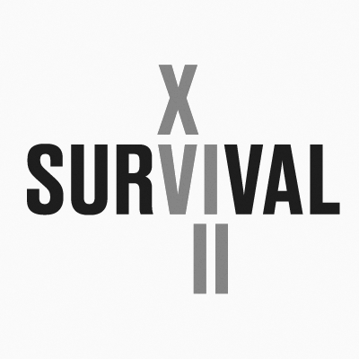

SURVIVAL 18 ART REVIEW ENTRY FORM
name and surname:…...........................................................................................................
home address: …....................................................................................................................
e-mail address: …................................................................................................................
telephone: ….........................................................................................................................
website: …..........................................................................................................................
title of the work: …..............................................................................................................
description of the work (max. 2,000 characters): …..........................................................................................................................................
technical specification:
– estimated cost of the project: …..........................................................................................
– list of materials: ….....................................................................….......................................
– the work requires transport YES/NO*
please specify the planned route and size of the parcel………………………………………
(* delete as appropriate)

if multimedia will be used
– format and size of the file: …...............................................................................................
– duration of emitted material (in minutes): ….............................................................................
– is there sound / specification: …...............................................................................................
Does the artist agree to participate in the competition for the Audience Award: YES / NO*
(*delete as appropriate)
attachments
– portfolio / cv (optional)
– visualisation of the proposed project
project visualisations can be prepared on the basis of photographic material provided by the Organiser, available at www.survival.art.pl in the DOWLOAD tab
Files should be sent in jpg, png or pdf format, max. Size 10 MB

Please send your entry form to konkurs@survival.art.pl by 19 January 2020. The deadline is non-extendable.

Artists who will inform the Organiser about the necessity of providing transport during the assembly and disassembly of works are entitled to the reimbursement of travel expenses and accommodation cost, in accordance with the applicable provisions of the Rules and Regulations. Therefore, please provide detailed information concerning the planned route and dates of sojourn in Wrocław during the assembly of works: …………………………………………………………………………………………………………………
…………………………………………………………………………………………………………………
“I hereby accept the provisions of the Rules and Regulations of SURVIVAL 18 Art Review of 19 November 2019”

……………….
artist’s signature

