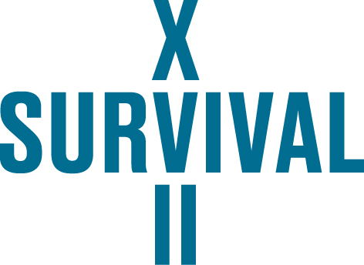

ENTRY FORM OF SURVIVAL 17 ART REVIEW

name and surname: …..........................................................................................................................
home address: …..................................................................................................................................
e-mail: ….........................................................................................................................................….
telephone: ….........................................................................................................................................
website: …............................................................................................................................................

title of the work: …...............................................................................................................................
description of the work (max. 2.000 characters): ….............................................................................
technical specification
– estimated cost of the project: ….........................................................................................................
– list of materials: ….....................................................................…....................................................
– will transport be required for the project YES/NO*
please specify the planned transport route and shipment size...............................................................
(*delete as appropriate)
if multimedia will be used
– format and size of the file: ….............................................................................................................
– duration of emitted material (in minutes): …..............................................................................................
– is there sound / please specify: …........................................................................................................
Does the artist agree to participate in the competition for the Audience Award: YES / NO*
(*delete as appropriate)

attachments
– portfolio / CV (optionally)
– visualisation of the proposed project
Project visualisations can be based on the Organiser’s photographic materials published on www.survival.art.pl in the tab DOWNLOAD. The files should be submitted in the jpg, png or pdf format and their total size should not exceed 15 MB.
In case of bigger size files, it is enough to provide a link to file download.

Please send your submission to konkurs@survival.art.pl by 15 February 2019.
Artists who will need to come to Wrocław in order to assemble and disassemble their works are eligible to the reimbursement of the cost of travel and accommodation in accordance with the provisions of the Rules and Regulations of the Review. Due to the above, please specify the route and dates of sojourn in Wrocław during the assembly:..........................................................................................................................................................................................................................................................................................................................................................................

“I accept the provisions of the Rules and Regulations of SURVIVAL 17 ART REVIEW of 12 December 2018.”

...................................
Signature of the entrant

